**Software Requirements Specification (SRS) Document**

|  |  |
| --- | --- |
|  | Project Name : Doctor Assist for EMRI Ambulance Client: Prakash Yalla (Product Lab)Mentor: Pravince Kumar Team Number : 39 Team Members :   1. Manan Garg (2022101109) 2. Bassam Adnan (2023121003) 3. Mayank Mittal (2022101094) 4. Uday Bindal (2022114015) 5. Shivam Mittal (2022101105) |

# :

# Brief problem statement

For every 25 patients, 1 doctor is assigned to them. The website should assist the doctors in case of critical cases and as and when the EMT assistant needs Doctor’s help. Create a web app for a doctor which shows the vitals of the patients. It should also have a document query which will help the doctor to find some medicine or procedure from a document uploaded on to the system by the admin. It should also have a live chat functionality with the EMT assistant with the patient.

# 

# System requirements

We will be using React and GraphQL for our implementation. Mongodb is being used as a database framework. For storing images used in chatting with EMT Assistants or storing documents uploaded by admins in Amazon S3 storage.

# Users profile

The platform will be mainly used by doctors which will show them the vitals of their patients and assist the doctor in case they want to get some information for example, they want to know which medicine the EMT assistant has to give to the patient for some symptom. They can also have live chat with the EMT assistant to tell them what steps to follow to help the patient.

The platform will also be used by the administrator who will upload documents for queries on the app and also upload doctor information to the database.

Also the admin can edit the activity status/view the document pdf, upload a new document or delete the documents uploaded anytime he or she wants.

# Feature requirements (described using use cases)

|  |  |  |  |
| --- | --- | --- | --- |
| **No.** | **Use Case Name** | **Description** | **Release** |
|  | Authentication | Facilitate the authentication of doctors and admins to the platform based on email and password. | R1 |
|  | View list of patients | Doctors have a sidebar accessible using which they can navigate through the list of patients present in each ambulance, each having a brief description of vitals and their problems. | R1 |
|  | View patient vitals | Doctors can view the vitals of the patient selected (such as blood pressure, heart rate, body temperature etc) on the case sheet ,and these would be posted by the EMT assistant present in the ambulance and can be updated anytime by EMT depending on patient health. | R1 |
|  | Criticality Judgment | Based on the vitals of a patient, updated dynamically in real-time, judgment on the condition of patient is passed on and the list of patients dynamically changes to view more severe patients on the top of the list and less severe on bottom. | R2 |
|  | Doctor performing a query | Doctors can chat with a LAMA model, which would be trained on files, and ask the model to reply with whatever they might need to know (like medicine to be taken). The responses captured may be forwarded (with an option of editing) to the EMT Assistant. | R2 |
|  | Doctor assisting the EMT assistant | EMT Assistants can chat(Text/Voice) with the doctors for assistance. The doctor can guide the assistance on steps to be taken next. | R1 |
|  | Audio Capture | Doctors have the option to record audio and send it to the assistant in the chat page. | R2 |
|  | Upload Manuals | An administrator may be given a page to upload documents for the LAMA model and can also delete them or edit their activity status. | R2 |

**Use case diagram**

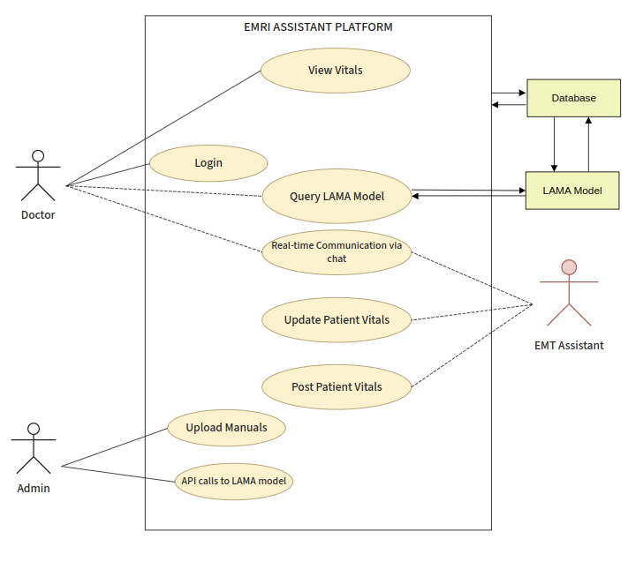

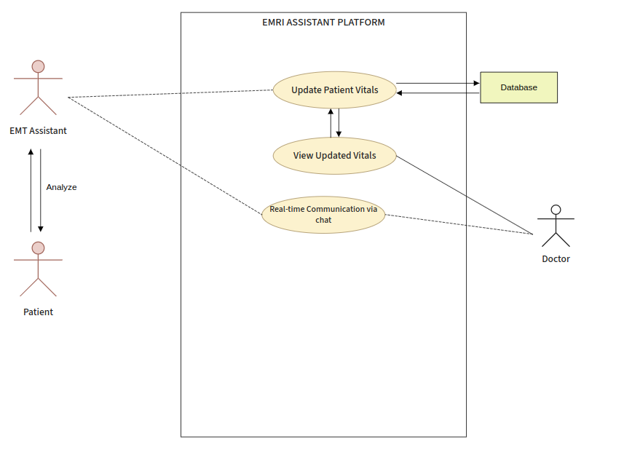

Another use case where the EMT analyzes the patient and then updates the vitals. The doctor can then view these vitals which are updated in the database as well.

**Use case description**

|  |  |
| --- | --- |
| **Use Case Number:** | UC-01 |
| **Use Case Name:** | Authentication |
| **Overview:** | The entered details by the doctor’s has to be valid and the authentication will be done by verifying the details from the Database. |
| **Actors:** | Doctor, Admin ,Database |
| **Pre condition:** | 1. The authentication system must be initialized and operational. 2. The doctor or admin must have previously registered with the system and must possess valid login credentials 3. The system must have a stable network connection to verify the doctor's or admin’s credentials. |
| **Flow:** | Main (success) Flow:   1. Doctor or admin enters the login credentials (email and password). 2. The email is searched in the database and if it exists then the password for the same is matched with the input password. 3. If the password is correctly matched then the main webpage is loaded. |
|  | Alternate Flows: An error message of incorrect or invalid email/password is displayed and the user will be allowed to enter the credentials again. |
| **Post Condition:** | The main webpage having the details of the patients of all the ambulances associated with that doctor is loaded or admin dashboard will be displayed with list of all uploaded documents. |

|  |  |
| --- | --- |
| **Use Case Number:** | UC-02 |
| **Use Case Name:** | View list of patients details |
| **Overview:** | Once the doctor has logged in, a web page must appear with the left most sidebar having the list of patients associated with the 25 ambulances of the doctor. |
| **Actors:** | Doctor, Database |
| **Pre condition:** | The doctor must be logged in and the details of the patient must be uploaded by the EMT assistant. |
| **Flow:** | Main (success) Flow:   1. For all the patients in the 25 ambulances, their health problems, age, age-type (old/young),gender,ambulance number and the time at which the patient was entered into the ambulance must be displayed. 2. There must be a color for each case of patient (Red/Yellow/Green) based upon the criticality, red being the most critical, yellow being moderate and green being the minor case 3. The details of the patients must be displayed in a sorted order of criticality with red being displayed first and green at the last. 4. This sidebar must have its own scroll bar for scrolling and viewing the details of all the patients. 5. This must have a drop down option upon clicking on a patient. The drop down will contain LOC,Criticality,past history,signs & symptoms,ERCP advice and events during transport information. |
|  | Alternate Flows: None |
| **Post Condition:** | When any patient information is clicked then the details of the patient must appear in the drop down and the vitals must be displayed on the bar adjoining it. |

|  |  |
| --- | --- |
| **Use Case Number:** | UC-03 |
| **Use Case Name:** | View patient vitals |
| **Overview:** | The vitals that are recorded by the EMT assistant must be displayed in this section. |
| **Actors:** | Doctor, Database |
| **Pre condition:** | One patient must be clicked from the leftmost sidebar whose details are to be viewed and the details for that patient must have been uploaded by the EMT assistant. |
| **Flow:** | Main (success) Flow: When a patient is clicked from the left most side bar, the vitals of the patient must be displayed. The vitals are the following :-   1. Body Temperature (in F) 2. Blood Pressure (Systolic and Diastolic in mm/Hg) 3. Pulse (in Rate/min) 4. Rhythm (Regular/Irregular) 5. Volume (Thready, Normal) 6. Respiration (in Rate/min) 7. Adventitious Sounds (Creps, Rhonchi, Normal) 8. Reaction to light (Brisk,Sluggish,Non reacting) 9. Left Air Entry (Yes/No) 10. Right Air Entry (Yes/No) 11. RBS (in mg/dl) 12. Spo2 13. Pupil Size (Normal,Constricted,Dilated) 14. Condition (Critical/Normal) 15. Skin Colour (Pink/Dusky/Cyanotic) |
|  | Alternate Flows: None |
| **Post Condition:** | None |

|  |  |
| --- | --- |
| **Use Case Number:** | UC-04 |
| **Use Case Name:** | Criticality Judgment |
| **Overview:** | Based on the vitals of a patient, updated dynamically in real-time by EMT Assistant, it judges the condition of the patient and the list of patients dynamically changes to view more severe patients on the top of the list.  Also the color- red/yellow/green will be dynamically displayed in patient details |
| **Actors:** | Doctor, EMT Assistant, Database |
| **Pre condition:** | 1. EMTs must be available and equipped to measure and transmit patient vitals in real-time. 2. There should be a stable and reliable communication network between the EMTs and the doctors to transmit vital data without delay. 3. The vitals transmitted by the EMT must be valid and accurately measured. |
| **Flow:** | Main (success) Flow:   1. Firstly, EMT Assistants of all ambulances which are having patients measure the patient's vital signs and transmit it to the Doctor in real-time. 2. Then according to the threshold values for each vitals, the criticality of the patient will be determined dynamically. 3. Based on criticality, the respective color coding of red for critical,yellow for moderate and green for minor is displayed in patient details and this will be updated in real-time. |
|  | Alternate Flows: Each time the Doctor gets any new vital details of any patient ,the judgment system will update the criticality of respective patients. |
| **Post Condition:** | 1. The judgment system provides the doctor with the criticality assessment of the patient based on the transmitted vitals. 2. It will prioritize patients based on their criticality level to ensure timely medical attention by ensuring most critical patients at top and minors at bottom. |

|  |  |
| --- | --- |
| **Use Case Number:** | UC-05 |
| **Use Case Name:** | Doctor performing a query |
| **Overview:** | The doctors can chat with the LAMA model which is trained on the documents uploaded by the admin and get results based on the prompts the doctors give (like what medicine to give) |
| **Actors:** | Doctors, LAMA Model |
| **Pre condition:** | 1. The doctor should be able to enter prompts into the textbox given to chat with the LAMA model. 2. The doctor enters relevant prompts related to medical sciences. 3. Doctor has good internet connectivity. |
| **Flow:** | Main (success) Flow:   1. The doctor enters the prompt and sends it to the LAMA model. 2. The LAMA model searches the prompt through it and checks within its data about the information regarding the prompt. 3. LAMA model displays in the chat all the relevant data it finds about the prompt and sends it to the doctor. |
|  | Alternate Flows: Doctor can send the results obtained from LAMA model to the EMT’s also. |
| **Post Condition:** | None |

|  |  |
| --- | --- |
| **Use Case Number:** | UC-06 |
| **Use Case Name:** | Doctor assisting the EMT assistant |
| **Overview:** | The doctor will suggest medication and other tasks such as dressing etc. to the EMT assistant. |
| **Actors:** | Doctor, EMT Assistant |
| **Pre condition:** | The Doctor has to click on the chat option available. |
| **Flow:** | Main (success) Flow:  Whenever the doctor clicks on the chat option, a chat box is opened where the doctor can chat with the EMT assistant. The EMT assistant can ask the doctor for medication and also inform about the condition and changes happened in the condition of the patient. |
|  | Alternate Flows: Doctor can also send images or voice messages over chat to the EMT Assistants |
| **Post Condition:** | When the message is sent, the EMT assistant will get the message on his app. |

|  |  |
| --- | --- |
| **Use Case Number:** | UC-07 |
| **Use Case Name:** | Audio Capture |
| **Overview:** | The doctor should be able to record audio and send it to the EMT assistant |
| **Actors:** | Doctor, EMT Assistant |
| **Pre condition:** | Doctor is authenticated |
| **Flow:** | Main (success) Flow:   1. Doctor clicks on the mic-icon and is prompted to audio capture. 2. The captured audio is sent to the chat page. |
|  | Alternate Flows: N/A. |
| **Post Condition:** | The EMT assistant should be able to hear the captured audio sent by the doctor, it should also appear on the chat page. |

|  |  |
| --- | --- |
| **Use Case Number:** | UC-08 |
| **Use Case Name:** | Upload documents |
| **Overview:** | The admin has the functionality to add documents, using which the LAMA model may give advice/suggestions on scenarios to the doctor based on the vitals |
| **Actors:** | Admin, Database, Amazon S3 storage service(external system) |
| **Pre condition:** | Admin has direct access to the database to upload the document. |
| **Flow:** | Main (success) Flow:  1. Select a document to be uploaded  2. Upload the document  3. Can view the uploaded documents , change their activity status or delete them on dashboard. |
|  | Alternate Flows: The uploaded documents will be stored in S3 storage and their URLs in Mongo DB. |
| **Post Condition:** | The LAMA model fetches instructions from this new document on the future queries made by the doctor. |